

**Sample Project Management Report**

**January 12, 2022**

**Team #**

**Member 1**

**Member 2**

**Member 3**

**Member 4**

**Member 5**

|  |  |
| --- | --- |
| Business Understanding | Pg. no |
| Problem Statement | Pg. no |
| Overarching Objective(s) | Pg. no |
| Project Management | Pg. no |
| * Team Members | Pg. no |
| * Project Timeline (Simple Table, Waterfall Chart, Trello, Microsoft Project, Asana, Etc.) | Pg. no |
| * Project Outcomes (Milestones) | Pg. no |
| * Project Strategy | Pg. no |
| * Risks and Challenges | Pg. no |
| Key Takeaways | Pg. no |

**NOTE: This is a sample template for project management report. You don’t have to follow the same design. Please discuss with your team and come up with your own.**

|  |  |
| --- | --- |
| **Business Understanding** |  |

|  |  |
| --- | --- |
| **Problem Statement** |  |

|  |  |
| --- | --- |
| **Overarching Objective(s)** |  |

|  |  |
| --- | --- |
| **Project Management** |  |

|  |
| --- |
| **Team Members** |

|  |
| --- |
| **Project Timeline** |

Project Timeline will be your project schedule. It will mostly follow the course schedule.

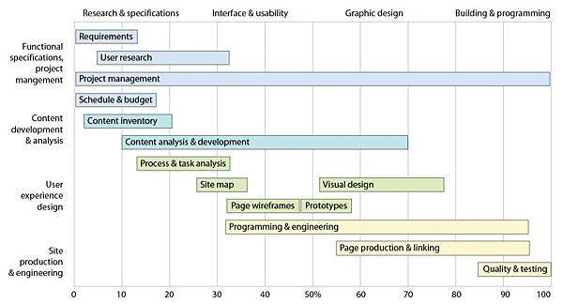

Image reference - https://www.pinterest.com/pin/33073378487247792/

|  |
| --- |
| **Project Milestones** |

Project Milestones are specific achievements. Milestones will help you track your progress and estimate the time it will take to complete the project.

|  |
| --- |
| **Project Strategy** |

Description of how the team plans to achieve the project objectives.

|  |
| --- |
| **Risks and Challenges** |

|  |  |
| --- | --- |
| **Key Takeaways** |  |

